* Hello wanderer lets do some training. Tap to continue.
* To strike swipe on the right side of the screen
* Great! That was a perfect attack. Now be quick and strike again!
* Too bad! That wasn’t a perfect attack the monster took damage but your combo was interrupted. get ready to defend yourself. Tap to continue.
* Watch your enemy and parry its attack by swiping or tapping on the left side of the screen at the moment the attack lands. It’s the monsters turn to attack you now. Tap to continue.
* You were too late. you should have swiped UP (left or right, down) on the left side of the screen. Tap to try again.
* Success. Tap to continue.
* Its your turn to attack again. Each monster has a perfect combo that will kill it instantly. Try to figure it out. Tap to continue.
* That wasn’t it. Tip: the arrows under the enemy health bar show you if you made a correct input. Tap to try again.
* You still got. Now let’s hunt some real monsters. Tap to continue.
* Hello wanderer, welcome to the world of yokai. Let’s start with the basics.
* First thing. the controls divide the screen into two parts the right side for attacks.
* And the left for defence
* Let’s start with an attack. Swipe on the right side of the screen.
* Great that was a perfect attack. Every attack also does a bit of damage.
* Let’s try another attack. This time swipe in any of the four directions.
* Sadly, that wasn’t a perfect attack. Whenever you don’t get a perfect attack, the enemy will take their chance to strike back. This will also happen whenever you take too long to attack.
* Now let’s defend. Defending takes place on the left side of the screen.
* There are three attacks that can come from enemies (High, Mid, Low) and your defence swipe needs to match their attack. Let’s try it.
* Timing is important. try again until you can defend from all three directions.
* Great! Now its your turn to attack again. This time lets try to get a perfect combo.
* Under the enemy health bar is the combo counter, it helps you to know which attacks where perfect and those that weren’t. go ahead and give it a shot.
* You got it! Whenever you get a perfect combo together it will also result in the enemy instantly dying
* Now that you know your way get out there and vanquish some real yokai.

Fade to black

# Best

ザシュ, ざしゅ

ササン, ささん

ザン, ざん

ザンッ, ざんっ

# Kinda work

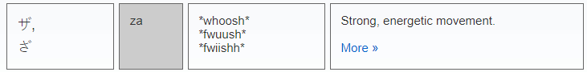

ザ, ざ

# IDK

ザシ, ざし

<http://thejadednetwork.com/sfx/index/sa>